

**Install Guide**

**Order Tracking**

Prepared by: Andromeda Trading Ltd

Date:

Version:

INDEX

INDEX 2

1 Revision Control 3

1.1 Document Approval 3

2 Introduction 4

2.1 Purpose 4

2.2 Scope 4

2.3 Definitions and Abbreviations 4

2.4 References 4

2.5 Overview 4

2.6 Contact Details 4

3 Introduction 5

4 Outlet installation 6

4.1 File Installation 6

4.2 The in store GPS map application 6

5 Rameses Configuration 7

5.1 Enabling or disabling order tracking and GPS tracking 7

5.2 Enabling or disabling the GPS tracking map application 10

6 Andromeda central server configuration 11

# Revision Control

| **Revision** | **Description of Changes** | **Revised By** | **Signed Off** | **Date** |
| --- | --- | --- | --- | --- |
| 1.0 |  |  | No |  |
|  |  |  |  |  |
|  |  |  |  |  |

## Document Approval

|  |  |  |  |
| --- | --- | --- | --- |
| **Signatory** | **Designation** | **Signature** | **Date** |
| Ben Cole | CIO |  |  |
| Ben Portsmouth | CEO |  |  |

# Introduction

## Purpose

The purpose of this documentation is to guide users through Order Tracking and to be used for training purposes for clients

The following details that will be included in this document:

* Process flows for the system
* Explanation of processes
* Screen Explanations
  + Detailing each field
  + Detailing buttons/commands that can be run from screen
  + Definitions of Data Headings

## Scope

This document will cover the available Order Tracking functionality in version X.X.

## Definitions and Abbreviations

|  |  |
| --- | --- |
| **Abbreviation** | **Description** |
| Order Tracking |  |
| Rameses | Andromeda’s POS system |
|  |  |

|  |  |
| --- | --- |
| **Concept** | **Definition** |
|  |  |
|  |  |
|  |  |
|  |  |
|  |  |
|  |  |
|  |  |

## References

|  |  |  |
| --- | --- | --- |
| **Document Name** | **Version** | **Date** |
|  |  |  |
|  |  |  |

## Overview

This document is designed to be used for user reference and training

## Contact Details

For further information please contact Andromeda Trading Ltd on

+44 (0)870 118 8010

or visit

<http://www.androtech.com>

# Introduction

There are several tasks that need to be carried out to install order tracking in an outlet:

1. Rameses must be upgraded to a version that supports order tracking
2. The store must have an internet connection
3. If the store will be using the in store GPS tracking map then either a new Rameses PC needs to be installed (which will be used only for the GPS map) or a second monitor needs to be added to an existing Rameses PC
4. Rameses must be configured to enable order tracking and/or GPS tracking
5. The outlet must be added to the Andromeda central server

# Outlet installation

## File Installation

Rameses includes a new .NET based installer that manages optional components such as order tracking and Loyalty. These components are all external to Rameses but some interact directly with Rameses.

All the files required by a component are packaged into an install package (7z file) and these install packages are included with Rameses. When a component is enabled in Rameses (see Rameses Configuration), the component installer automatically unpacks the required files and installs them. When a component is disabled in Rameses the component files are automatically uninstalled and deleted. The installation is completely automatic and covers things like registering the required dlls, installing, starting and stopping Windows services and setting folder permissions.

Since the .NET based installer automatically installs and uninstalls components, there should be no manual file installation required.

## The in store GPS map application

If the GPS map application is enabled (see Rameses configuration), when Rameses starts up it also launches a separate GPS map application. This application is designed to run full screen and cannot easily be used on the same monitor as Rameses.

The recommended option is to run the GPS map application on a dedicated machine. Under this configuration (see Rameses configuration), Rameses still runs to enable system reboots and updates but is hidden, allowing the GPS map full use of the monitor. The machine does not need to be especially powerful but it is a good idea to attach a fairly large monitor to it so that the GPS map can be easily seen from around the outlet.

The alternative option is to attach a second monitor to a machine already running Rameses. Rameses would be displayed on the primary monitor and the GPS map would be displayed on the secondary monitor. Please note that it is not a good idea to add a second monitor to a low spec machine.

If a second VGA/DVI port is not available on the machine or a second graphics card cannot be added then a USB VGA splitter can be used. Be aware that there may be limitations on the screen resolution supported – it may struggle to drive a large monitor. USB VGA splitters can also cause increased CPU usage as the CPU takes on tasks for the second monitor that would ordinarily be handled by the graphics card.

# Rameses Configuration

Order tracking and/or GPS tracking must be enabled for the store as follows.

## Enabling or disabling order tracking and GPS tracking

On the server, log in as a system user, then go to the manager menu.

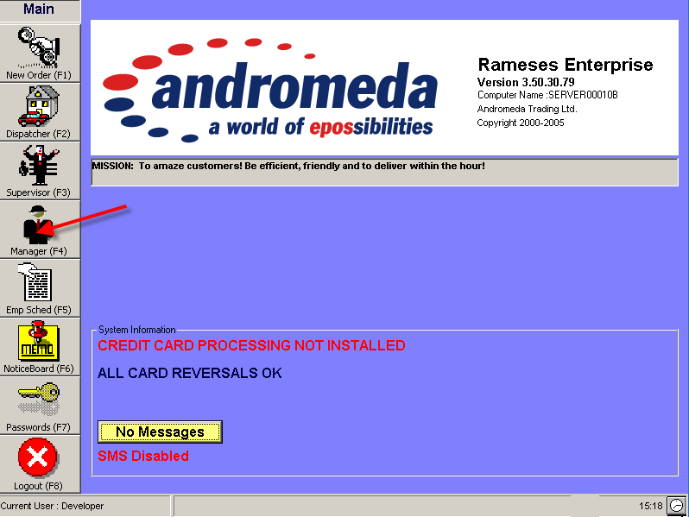

Then go to the settings menu.

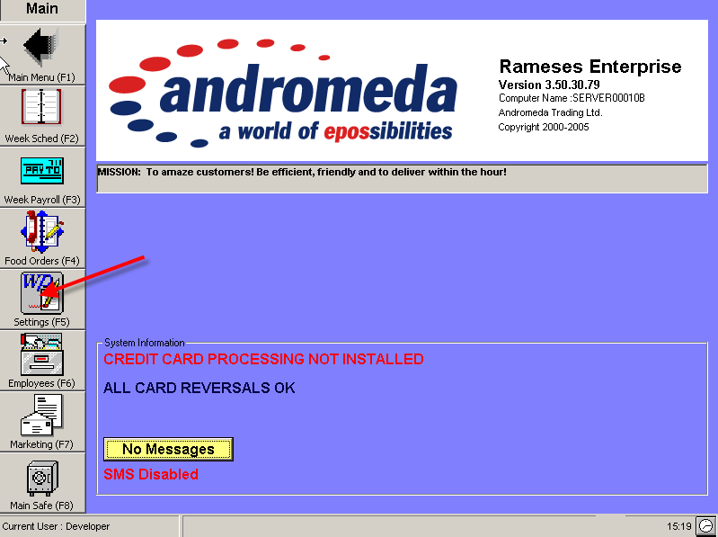

Go into devices.

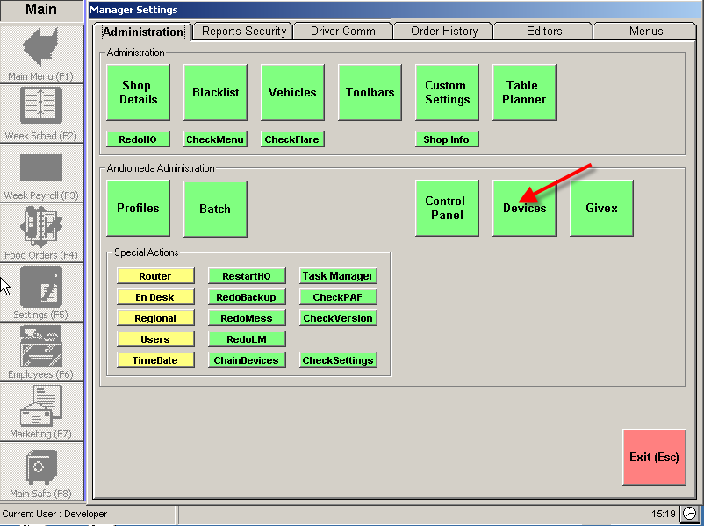

There are two Rameses integration modes available: “Andromeda Order Tracking” and “Andromeda GPS Tracking”. “Andromeda GPS Tracking” includes all the features of “Andromeda Order Tracking” but includes additional GPS tracking features.

Select the ‘External’ radio button underneath the Device Categories list box and then select ‘Order Tracking’ from the Device Categories list above. Select either “Andromeda Order Tracking” or “Andromeda GPS Tracking” from the drop down combo under “Installed Devices”.

NOTE: THIS AREA HAS BEEN DEPRECIATED IN THE WEBSERVICE, THIS IS POINTLESS AS IT DOESN’T CHANGE ANYTHING ON THE WEBSERVICE

Click the small green square  followed by the save button.

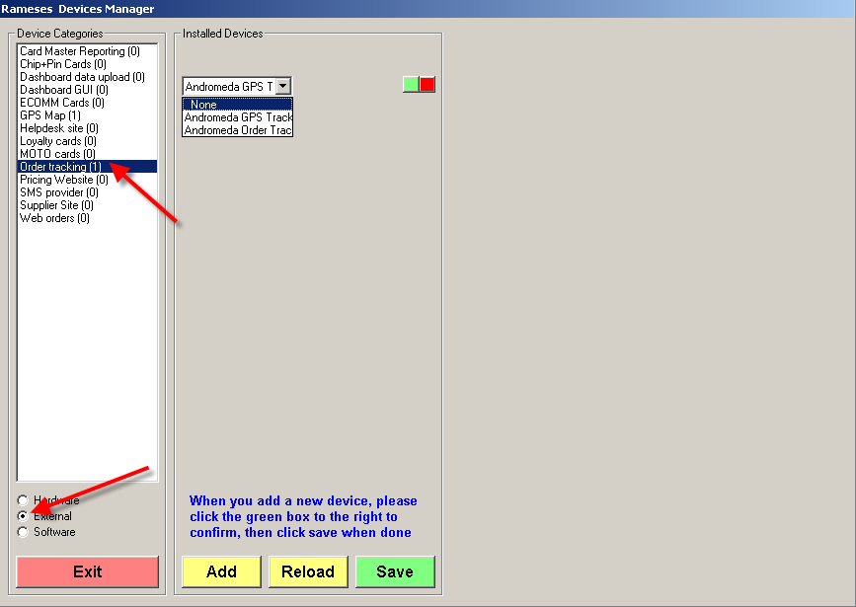

## Enabling or disabling the GPS tracking map application

If you enable “GPS Map”, Rameses will automatically launch the GPS tracking map on start-up.

There are two modes available. If you intend to use a dedicated machine to run the GPS tracking map application then select “GPS Map No Rameses”. Rameses will run in the background to enable system reboots and updates.

If you intend to run the GPS tracking map application on the 2nd screen of a machine that is running Rameses then select the “Main GPS Map 2nd Screen” option.

Select an option and then click the small green square  followed by the save button.

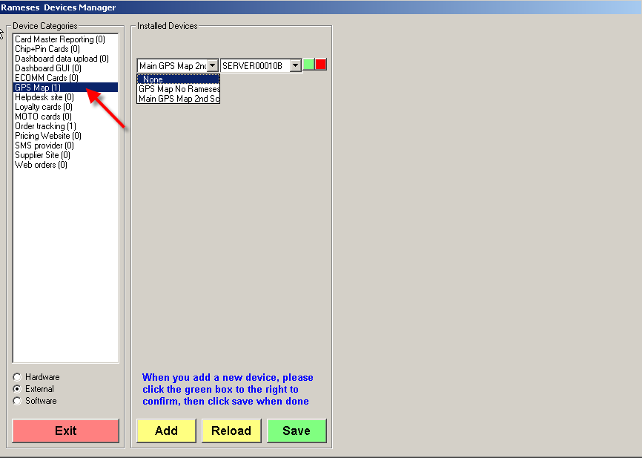

# Andromeda central server configuration

You will need to add the store to the central server as follows:

<http://admin.androtechnology.co.uk>

You will be given login details by a system administrator. If you have permissions to use the Order Tracking Admin area, then you can follow the sequence below.

Login -> Order Tracking -> Add Store

You should be presented with this view:

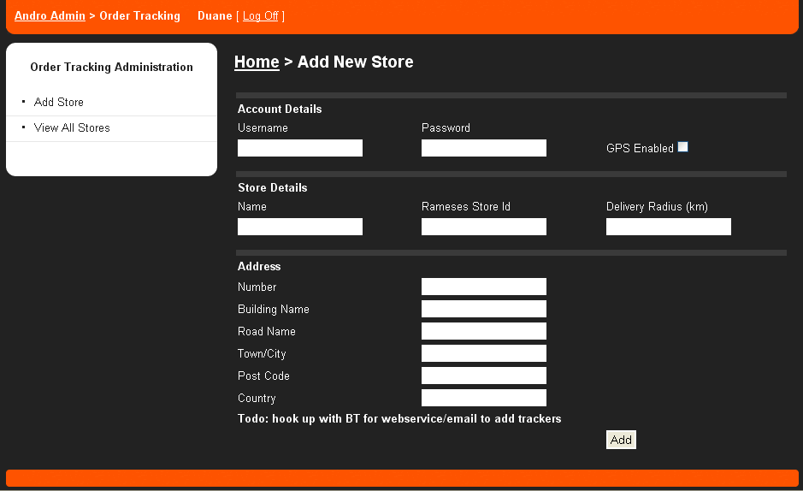

**Account Details:**

Username: This is ‘MONITOR’ + RamesesStoreId. For example as username of, MONITOR4 is Herbies Slough.

Password: This is ‘PASS’ + RamesesStoreId, Again an example of this would be PASS4, which again is Herbies Slough.

GPS Enabled: If the store has trackers assigned, then select this box.

**Store Details:**

Name: The name of the store.

Rameses Store Id: The internal Id of the store. Eg, 4 is Herbies Slough.

Delivery Radius (km): Usually set at 7. This is the catchment area for all orders. This is used for Geo-Coding customer addresses within that area. If a customers address falls outside this is because they are either too far away to deliver too, or that the address has been in-correctly Geo-Coded.

**Address**

Fill this out as best as possible, but make sure that the country is explicitly set in CAPITALS, as UNITED KINGDOM. Currently the UK is the only country supported, and due to technical reasons the country must be filled out as above.

The address is used to Geo-Code the store’s location. You will be able to edit this location later if needed.

If you have any problems, please consult the Order Tracking Support Guide.

**Future Development**

Blackberry/IPhone enabled admin area.

When a new store that is going to have GPS Trackers, it requires a long undocumented process with BlueTree, and a server re-boot on their end. Ideally this should be part of the setup area, we are waiting on a webservice call to facilitate.

Currently under development is the external ‘Client Tracking Area’, an example of this is:

<http://ordertracking.androtechnology.co.uk/Track/Herbies/>

The admin area will contain all the necessary information to create new tracking areas based on chains (eg. Herbies, TBBC, PapaJohns). This process at the moment is a 20 minute job for a developer.

This area can be integrated into existing sites via a popup, or external developers can create their own client order tracking area using an example call below:

[http://ordertracking.androtechnology.co.uk/Track/{ChainName}/GetOrder/{Client_Order_Tracking_Number}](http://ordertracking.androtechnology.co.uk/Track/%7bChainName%7d/GetOrder/%7bClient_Order_Tracking_Number%7d)